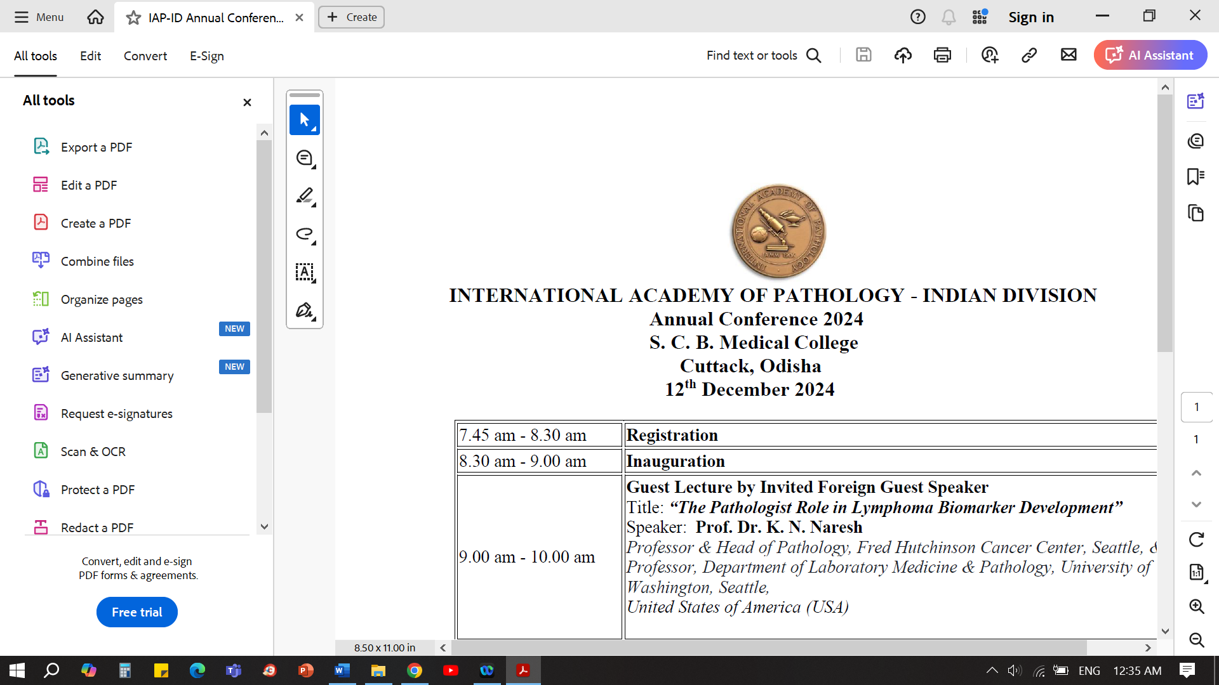
Slide seminar programme
[10.30-12.30 pm ]

Topic: The Mighty Little Vermiform Appendix: Its Pathology and Frontiers
Moderator: Dr. Usha Kini, Bengaluru

Introduction : Dr Usha Kini, Bengaluru
Part 1: " And Lo! the Mighty Appendix in Little Adults"
Dr Usha Kini, Bengaluru

Part 2: "The little Devil and it's Bag of Tricks"
Dr K P Aravindan, Calicut

Part 3 : ”Mucinous maladies to peritoneal pandemonium - the hidden dangers of
appendix tumours”

Dr Paromita Roy, Kolkota

Closing remarks: Dr Usha Kini, Bengaluru
Q & A

- XXXX-

